Marmara University
Engineering Faculty
Electrical and Electronics Engineering
EE4077: Fundamentals of Machine Learning

Midterm Exam 2 (Spring, 2023)
- [25 pts] Perform $K$-means clustering algorithm (there are two classes) on the two-dimensional dataset given below. Circles are data points and there are two initial cluster centers, at data points 5 and 7. Draw the cluster centers (as squares) and the decision boundaries that define each cluster. If no points belong to a particular cluster, assume its center does not change. Use as many of the pictures as you need for convergence.

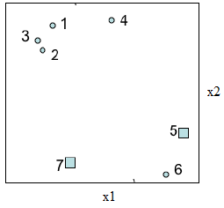
- In the following questions you will consider a $k$-nearest neighbor classifier using Euclidean distance metric on a binary classification task. We assign the class of the test point to be the class of the majority of the $k$-nearest neighbors. Note that a point can be its own neighbor. The 2-D dataset is given below. Points represented by plus (+) sign belong to one class and those represented by minus (-) sign belong to another class.

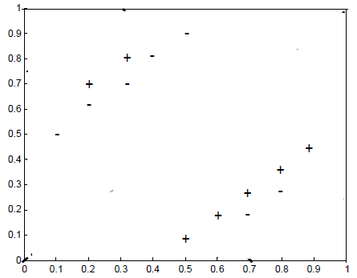

(a) [5 pts] What value of $k$ minimizes the training set error for this dataset? What is the resulting training error?
(b) [10 pts] Why might using too large values $k$ be bad in this dataset? Why might too small values of $k$ also be bad?
(c) [5 pts] What value of k minimizes leave-one-out cross-validation error for this dataset? What is the resulting error?
(d) [5 pts] Sketch the 1-nearest neighbor decision boundary for this dataset.

3. The goal of this problem is to correctly classify test data points, given a training data set. You have been warned, however, that the training data comes from sensors which can be error-prone, so you should avoid trusting any specific point too much. For this problem, assume that we are training an SVM with a quadratic kernel– that is, our kernel function is a polynomial kernel of degree 2. You are given the data set presented in the figure below. The slack penalty $C$ will determine the location of the separating hyperplane. Please answer the following questions qualitatively. Give a one sentence answer/justification for each and draw your solution.

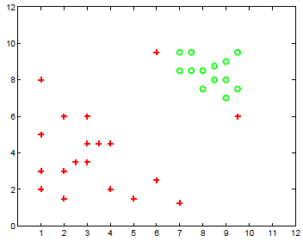

(a) [5 pts] Where would the decision boundary be for very large values of $C$ (i.e., $C → ∞$)? (remember that we are using an SVM with a quadratic kernel.) Draw on the figure below. Justify your answer.
(b) [5 pts] For $C ≈ 0$, indicate in the figure , where you would expect the decision boundary to be? Justify your answer.
(c) [5 pts] Which of the two cases above would you expect to work better in the classification task? Why?
(d) [5 pts] Draw a data point which will not change the decision boundary learned for very large values of $C$. Justify your answer.
(e) [5 pts] Draw a data point which will change the decision boundary learned for very large values of $C$. Justify your answer.

- In this problem, the following short questions should be answered with at most two sentences, and/or a picture. For the (true/false) questions, answer true or false. If you answer true, provide a short justification, if false explain why or provide a small counterexample.

(a) [5 pts] Discuss whether MAP estimates are less prone to overfitting than MLE.
(b) [5 pts] Consider a classification problem with two classes and $n$ binary attributes. How many parameters would you need to learn with a Naive Bayes classifier? How many parameters would you need to learn with a Bayes optimal classifier?
(c) [5 pts] For an SVM, if we remove one of the support vectors from the training set, does the size of the maximum margin decrease, stay the same, or increase for that dataset?
(d) [5 pts] true/false In $n$-fold cross-validation each data point belongs to exactly one test fold, so the test folds are independent. Are the error estimates of the separate folds also independent? So, given that the data in test folds $i$and$j$ are independent, are $e_{i}$ and $e_{j}$ , the error estimates on test folds $i$ and $j$, also independent?
(e) [5 pts] true/false There is an a priori good choice of $n$ for $n$-fold cross-validation.

